R Programming
Project Based Learning(PBL)
On
Analysis Food Delivery Data Using R Programming
Bachelor of Technology
In
Computer Science and Engineering(Data Science)
by
S.Laharika
23EG110C55
CSE(DS-C)
Under The Guidance of:
Mrs.D.Shanti Priya


Department of Computer Science Engineering (Data Science)
ANURAG UNIVERSITY
VENKATAPUR (V), GHATKESAR (M),
MEDCHAL- MALKAJGIRI (D), TELANGANA-500088.

INDEX
- Abstract …………………………………………………. 3
- Introduction……………………………………………… 4
- Objectives…………………………………………………… 5
- Dataset Description & Methodology …………………....... 6
- Data Analysis & Visualization……………………………….7
- Results………………………………………………………. 12
- Conclusion………………………………………………….. 12

ABSTRACT
Online food delivery platforms generate large volumes of operational and customer data. Analyzing this data helps improve delivery efficiency and customer satisfaction. This project analyzes food delivery data using R programming and visualization techniques. The dataset includes delivery time, ratings, age, traffic density, and city type. Data preprocessing and exploratory data analysis were performed using R libraries such as ggplot2 and dplyr. Various visualizations were created to identify patterns and trends in delivery performance. The analysis revealed that delivery time, traffic conditions, and city type significantly influence delivery efficiency and customer satisfaction. This project demonstrates the effectiveness of R programming for real-world data analysis.

INTRODUCTION
Online food delivery services have become an essential part of modern life, providing convenience to customers. These platforms generate large amounts of data related to delivery operations, ratings, and traffic conditions. Analyzing this data helps improve operational efficiency and service quality.
R programming is widely used for data analysis and visualization due to its powerful libraries and statistical capabilities. In this project, food delivery data was analyzed using R programming to study delivery time distribution, customer ratings, traffic impact, and performance across cities and age groups. The analysis provides insights into factors affecting delivery efficiency and customer satisfaction.

OBJECTIVES

The objectives of this project are:
Analyze food delivery data using R programming
• Study delivery time distribution
• Analyze customer ratings
• Study traffic impact on delivery performance
• Compare delivery performance across cities and age groups
DATA DESCRIPTION

The dataset contains 37,231 delivery records. It includes delivery time, delivery person age, ratings, traffic density, weather conditions, city type, and multiple deliveries. This data helps evaluate delivery performance and operational efficiency.

METHODOLOGY

The dataset was loaded and cleaned using R programming. Missing values were handled, and data types were converted. Exploratory data analysis was performed using visualization techniques such as histogram, bar chart, pie chart, heatmap, and boxplot. These visualizations helped identify patterns and trends in delivery performance.
DATA ANALYSIS AND VISUALIZATION

1.Load Required Libraries
library(ggplot2)
library(dplyr)
library(hms)
library(lubridate)
Why used
• ggplot2 → for charts
• dplyr → for data cleaning
• hms, lubridate → for time handling

2.Load Dataset
food_delivery_data<-read.csv(file.choose())
head(food_delivery_data)
str(food_delivery_data)

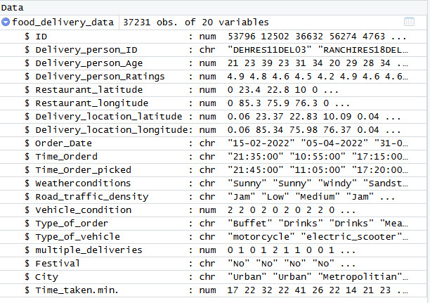
3.Clean Dataset
food_delivery_data <- food_delivery_data %>% distinct()
food_delivery_data$Order_Date
<- as.Date(food_delivery_data$Order_Date,format="%d%m-%Y")
food_delivery_data$Time_Orderd <- hms::as_hms(food_delivery_data$Time_Orderd)
food_delivery_data$order_hour <- lubridate::hour(food_delivery_data$Time_Orderd)

4.Delivery Time Distribution
ggplot(food_delivery_data,aes(x=Time_taken.min.)) +
geom_histogram(binwidth = 5,fill = "darkgreen",color = "black") +
labs(title = "Distribution of Delivery Time", x = "Delivery Time (min)",y = "Frequency")

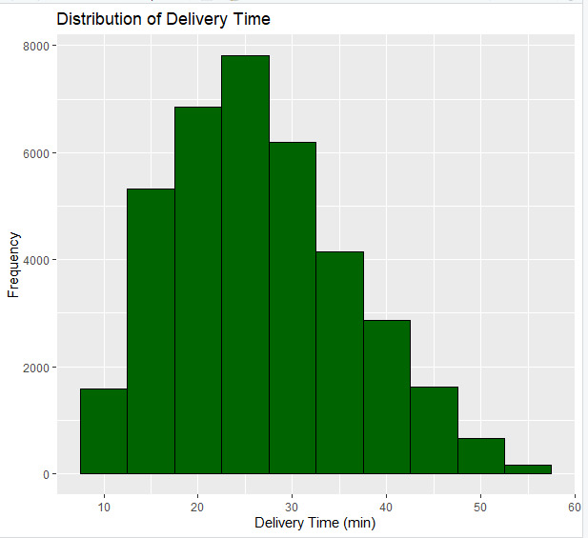

5.Delivery Person Ratings
ggplot(food_delivery_data,aes(x = Delivery_person_Ratings)) +
geom_bar(fill = "red",color = "black") +
labs(title = "Delivery Person Ratings", x = "Ratings",y = "Count")

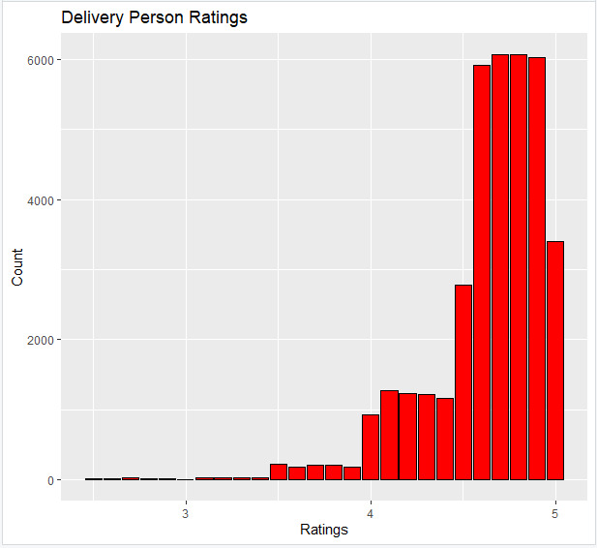

6.Orders by Road Traffic Density
traffic_density_counts <- food_delivery_data %>%
count(Road_traffic_density) %>%
mutate(percentage = n/sum(n)*100)
ggplot(traffic_density_counts,aes(x = "",y = percentage,fill = Road_traffic_density)) +
geom_bar(stat="identity", width=1) +
coord_polar("y") +
labs(title="Orders by Road Traffic Density") +
theme_void()
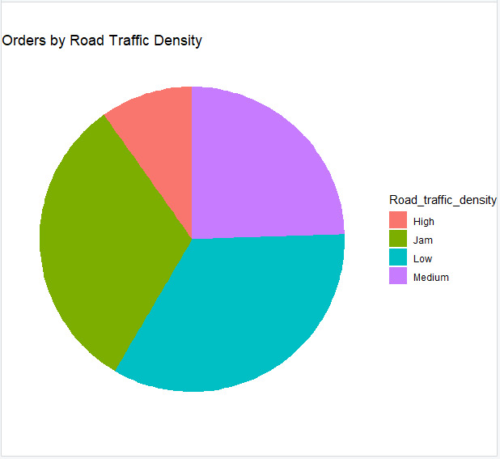
7.Multiple Deliveries Distribution
ggplot(food_delivery_data,aes(x = factor(multiple_deliveries))) +
geom_bar(fill = "darkgreen",color = "black") +
labs(title = "Distribution of Multiple Deliveries", x = "Multiple Deliveries",y = "Count")
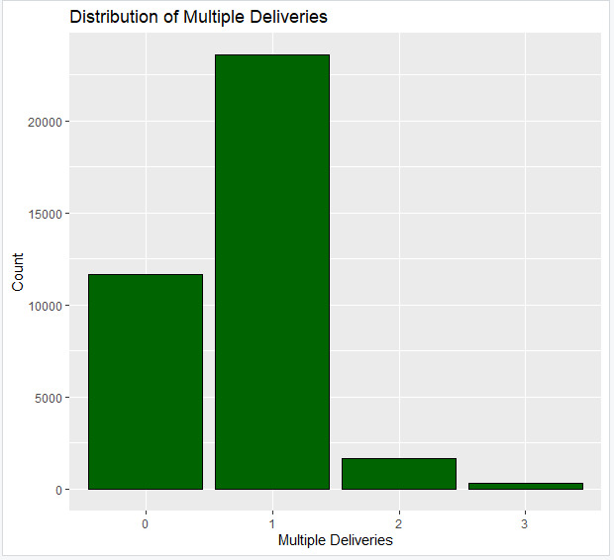
8.Average Ratings by City
rating_by_city <- food_delivery_data %>%
group_by(City) %>%
summarise(avg_rating =mean(Delivery_person_Ratings))
ggplot(rating_by_city,aes(x = City,y = avg_ratingfill = avg_rating)) +
geom_tile() +
labs(title = "Average Delivery Person Ratings by City",x = "City = "Average Rating")

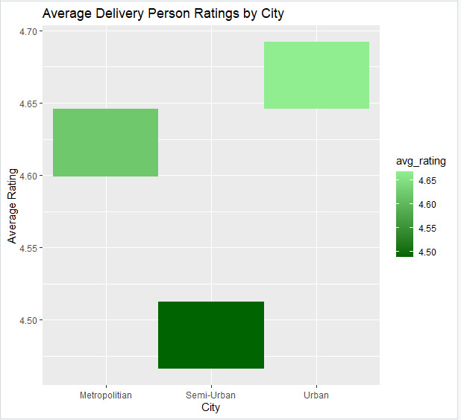
10.Ratings by Age Group
food_delivery_data <- food_delivery_data %>%
mutate(Age_Group=cut(Delivery_person_Age,breaks=c(20,25,30,35,40,45),labels=c("20-25","25-30","30-35","35-40","40-45")))
ggplot(food_delivery_data,aes(x = Age_Group,y = Delivery_person_Ratings)) +
geom_boxplot(fill="yellow") +
labs(title="Delivery Ratings by Age Group", x="Age Group",y="Ratings")
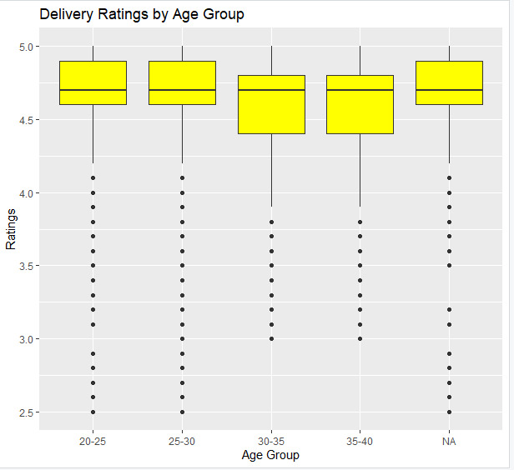

RESULT
The following results were observed from the analysis:
• Most deliveries are completed within 20–35 minutes, indicating that the delivery system operates efficiently and ensures timely service under normal conditions.
• Delivery personnel ratings are generally high, with most ratings above 4.5. This reflects a high level of customer satisfaction and indicates good service quality and reliable delivery performance.
• Traffic density has a significant impact on delivery time. Deliveries made under high traffic conditions take longer compared to those under low or medium traffic, highlighting the importance of efficient route planning.
• Urban areas show slightly better delivery performance compared to semi-urban areas. This may be due to better infrastructure, shorter distances, and improved road connectivity in urban regions.
• Delivery performance is consistent across different age groups. The rating distribution shows that delivery personnel of all age groups maintain similar levels of efficiency and service quality.
• Multiple deliveries affect workload distribution. Delivery personnel handling multiple orders simultaneously improve operational efficiency, but it may increase workload and slightly influence delivery time.
• Overall, the analysis indicates that the delivery system is efficient, with high customer satisfaction and stable performance. However, factors such as traffic density, city type, and workload influence delivery efficiency.

CONCLUSION
The analysis showed that delivery performance is generally efficient. Customer ratings are high, indicating good service quality. Traffic conditions and city type influence delivery efficiency. Delivery performance is consistent across different age groups.

